HOW TO APPLY HOSTEL GATE PASS
HOSTEL GATE PASS कैसे APPLY करें

Step-1: Open the Student App and tap the four dots in the center at the bottom of the screen.
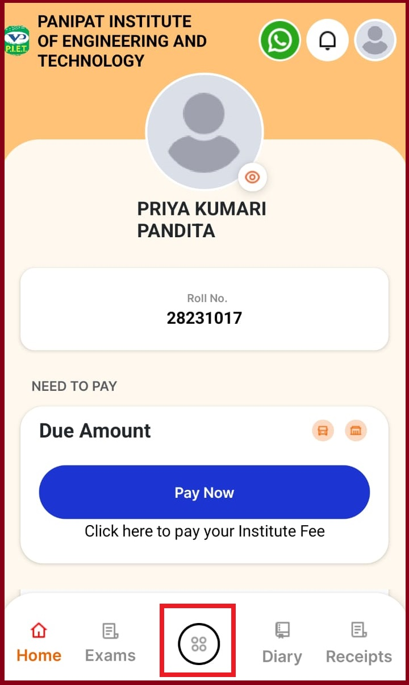

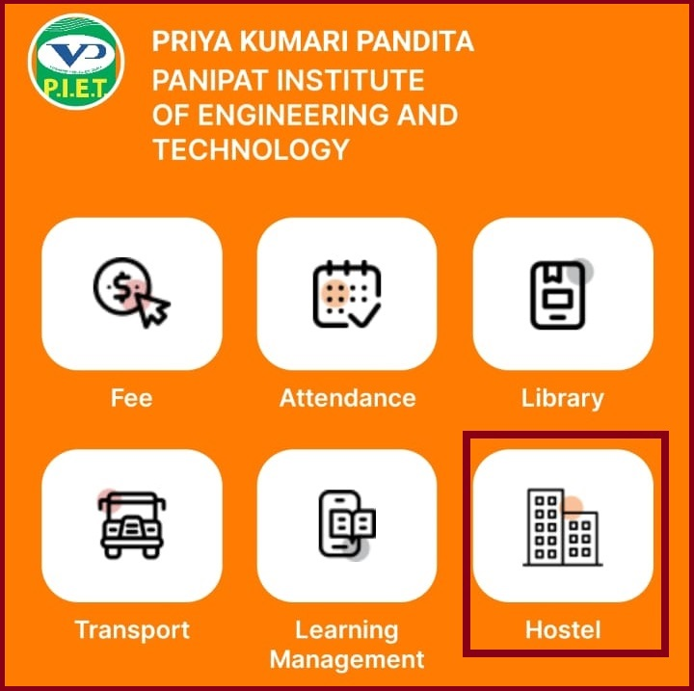
Step-2: Select the "Hostel" option.

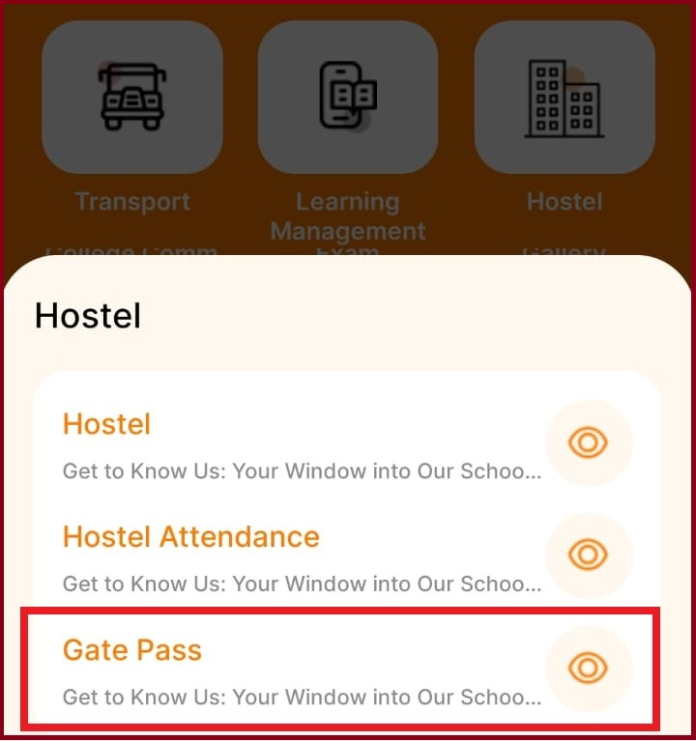
Step-3: Choose "Hostel Gate Pass."

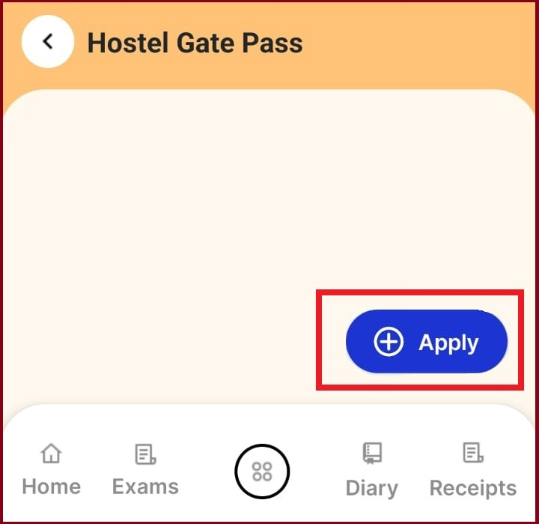
Step-4: Click the "Apply" button.

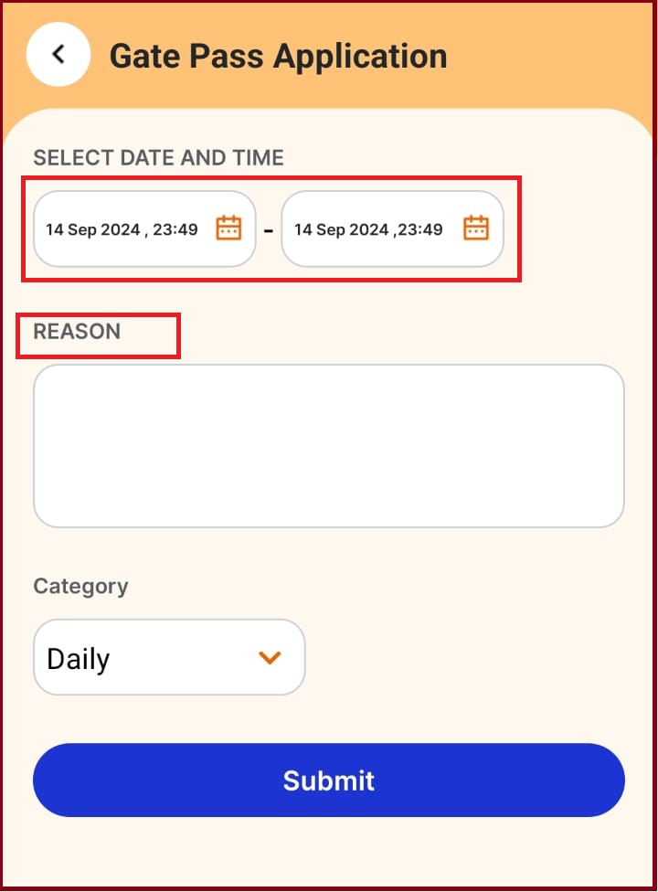
Step-5: Select the date and timing (from/to), enter the Reason.

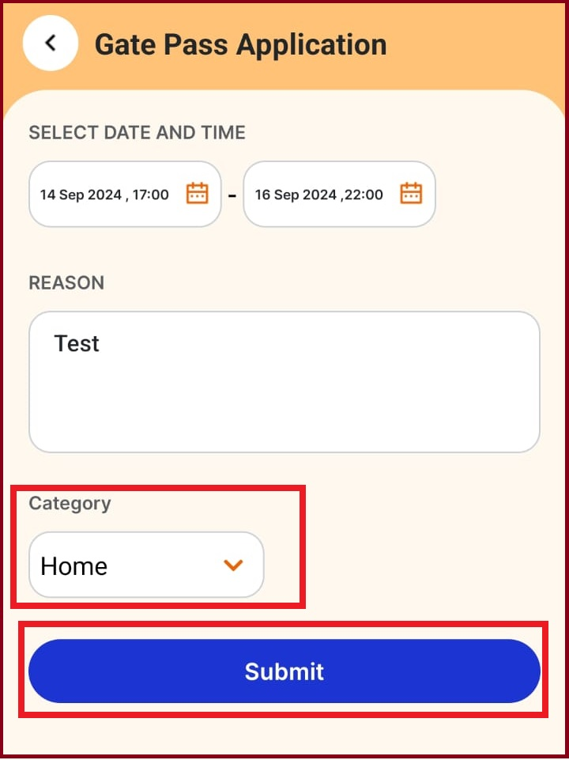
Step-6: Select the category, and click "Submit."

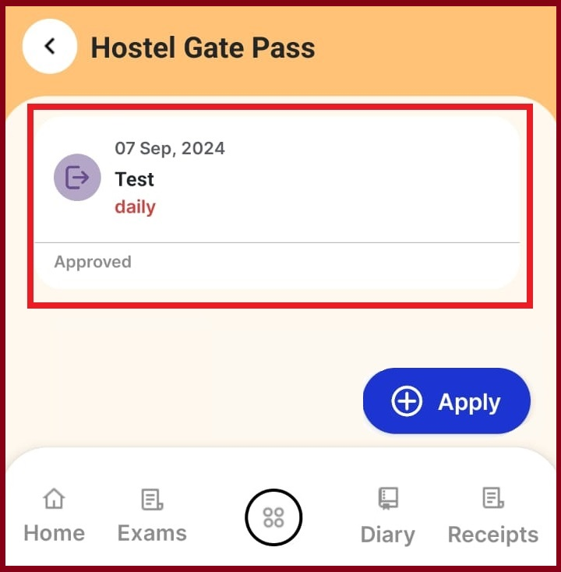
Step-7: Once your hostel gate pass is approved, you can access the QR code.

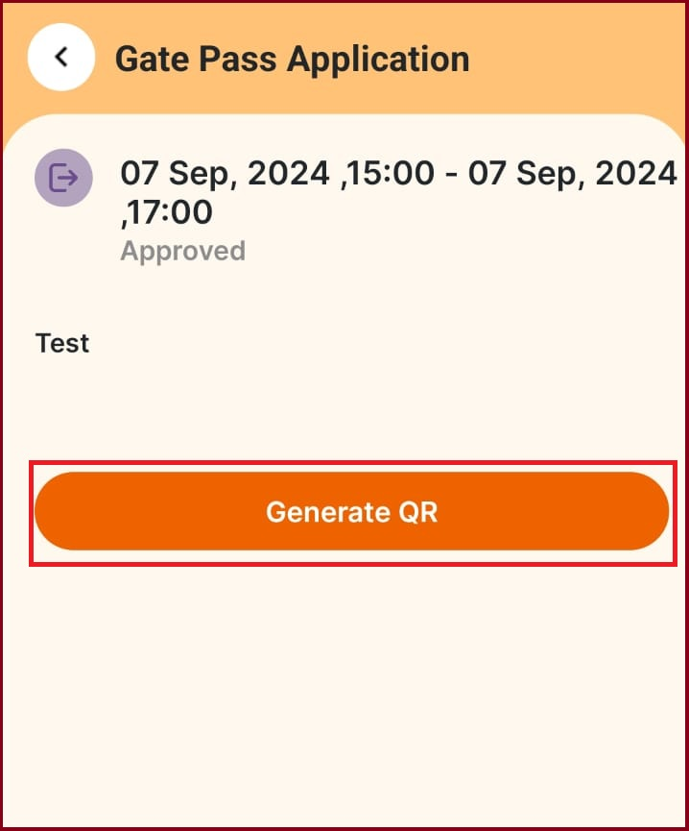
Step-8: Tap on "Approved Gate Pass" and click "Generate QR."


Step-9: Your QR code will now be displayed.

